Adding key:

Key:
Attempt | Input | Expected | Actual | P/F
1 | blank | Invalid input | Invalid input | P
2 | status | Add key | Add key | P

Attempt 1 screen shot
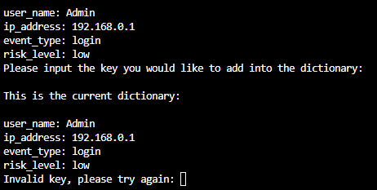
Attempt 2 screen shot
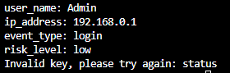

Value:
Attempt | Input | Expected | Actual | P/F
1
2

Attempt 1 screen shot:
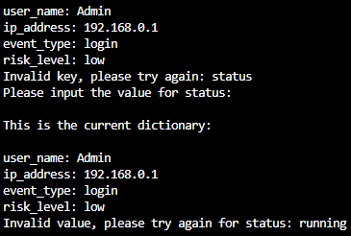

Attempt 2 screen shot:
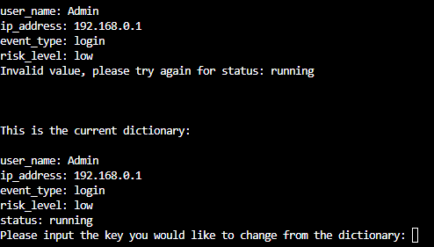

Change value from key:
Choosing the key:
Attempt | Input | Expected | Actual | P/F
1 | risk | Key not found | Key not found | P
2 | Blank | Invalid input | Invalid input | P
3 | risk_level | Key found | Key found | P

Attempt 1 screen shot:
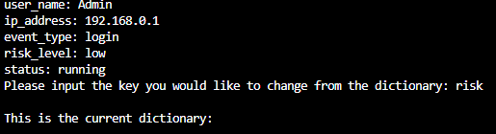

Attempt 2 screen shot:
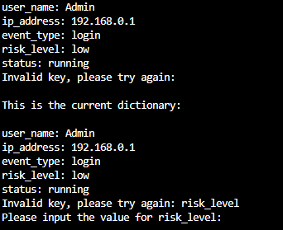

Attempt 3 screen shot:
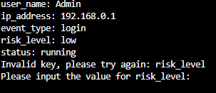

Changing the key:

Attempt | Input | Expected | Real | P/F
1 | blank | Invalid input | Invalid input | P
2 | High | Changed value | Change valu | P

Attempt 1 screenshot:
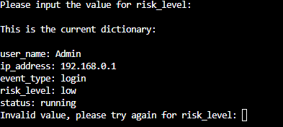

Attempt 2 screenshot:
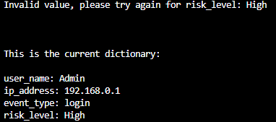

Deleting key from dictionary:

Attempt | Input | Expected | Actual | P/F
1 | Blank | Key not found | Key not found | P
2 | ip_address | Delete key | Delete key | P

Attempt 1 screenshot:
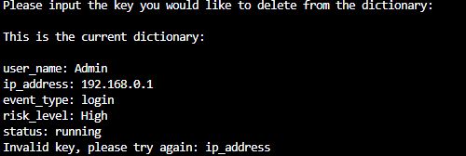

Attempt 2 screenshot:
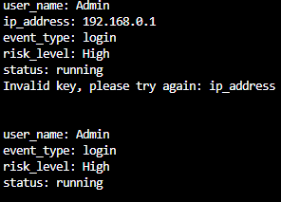

Ctrl + c

Attempt | Input | Expected | Actual | P/F
1 | Keyboard – ctrl + c | Program end | Program end | P

Attempt 1 screenshot:


